**Use of Machine Learning for Predicting Dyslexia based on eye tracking**

**while reading**

**Author**

*Parth Gawande, Student, MIT World Peace University, Pune, India.*

*Tanishq Borse, Student, MIT World Peace University, Pune, India.*

*Saket Desale, Student, MIT World Peace University, Pune, India.*

*Sarthak Bora, Student, MIT World Peace University, Pune, India.*

*Nitin Pise, Professor, MIT World Peace University, Pune, India.*

*Corresponding Author:Parth Gawande, Student, MIT World PeaceUniversity,Pune,India*

*.*-------------------------------------------------------------------------------------------------------------------------------------

**ABSTRACT**:

Dyslexia is a neurodevelopmental reading disability. Dyslexia is a widespread learning disability marked by a persistent problem with word recognition and spelling.Detection of dyslexia is critical, expensive. Early diagnosis of dyslexia is very important. Eye tracking may be a useful approach to detect dyslexic and non-dyslexic people. Because eye tracking does not rely on a person's verbal reaction, it is a natural way to examine the reading process objectively. Although dyslexia is a learning disability, eye movements in reading can predict individual reading ability. Eye tracking movements will be fed to the model for classification and will predict whether the person is dyslexic or not.

**KEYWORDS:**Classification, Dyslexia, Eye Tracking

1. **INTRODUCTION**

Although the reasons for dyslexia are as yet not completely comprehended, and definitions and terminology fluctuate,It is generally agreed that children who do not acquire reading skills at a normal rate require careful monitoring and support during the early years of school. Early identification and competent assistance are the greatest types of mediation for children with articulated comprehension issues, and it is dangerous to wait until children are officially diagnosed with dyslexia before addressing their needs. Thus we intend to create a system which predicts high risk and low risk of having dyslexia using machine learning and predictive modeling.

Dyslexia is a neurodevelopmental perusing inability assessed to influence 5 to 10% of the population[1]. While there is still no complete understanding of the cause of dyslexia or agreement on a precise definition, it is clear that many people have ongoing difficulties learning to read for no obvious reason.It is conceivable to recognize 9 to 10 year elderly people in danger of determined perusing troubles by utilizing eye tracking during perusing to test the cycles that underlie understanding capacity[1]. In spite of the fact that dyslexia is in a general sense a language-based learning inability,the findings suggest that reading eye movements can be a powerful predictor of individual understanding capacity, and that eye tracking can be a useful tool for identifying children at risk of long-term reading issues. before addressing their needs. Thus we intend to create a system which predicts high risk and low risk of having dyslexia using machine learning and predictive modeling.

The paper is divided into three sections. Section II contains a description of other work that has been done in studying dyslexia. Section III comprises a comprehensive description of the Datasets and the proposed system section IV contains the evaluation of the approach and comparison of different performance metrics . Conclusions about the study are stated in Section V.

1. **LITERATURE SURVEY**

In [1] that utilizes eye-tracking while reading to examine the mechanisms that underpin reading ability, we can identify 9–10-year-old persons at risk of chronic reading challenges. Unlike other screening methods that rely on spoken or written responses from the patient, eye tracking requires no overt verbal response from the patient and thus provides a natural way to objectively assess the reading process as it unfolds in real time. The research used a sample of 97 high-risk individuals who had previously reported word decoding difficulty, as well as a control group of 88 low-risk individuals. These topics were picked from a larger sample of 2165 second-graders. We use predictive modeling and statistical re-sampling methodologies to develop classification models utilizing eye-tracking records less than one minute in length, and show that the models can accurately distinguish high-risk participants from low-risk participants. Despite the fact that dyslexia is primarily a language-based learning disorder, the findings suggest that reading eye movements are highly predictive of individual reading ability, and that eye tracking could be a useful tool for identifying children who are at risk of long-term reading difficulties.

In [2] to make it more realistic, come up with a unique technique to display the user. Selecting the dyslexia stage, loading the treatments, and detecting gestures and speech are all topics covered in this study. The end results are majorly governed by a few technologies namely artificial intelligence, virtual reality, image processing and voice recognition. Anyone with dyslexia or who wants to improve their writing, reading, or speaking abilities can use "The Hope" with the help of a parent or guardian and experience major improvements by following the program's daily therapy. To incentivize and encourage users to use the programme on a daily basis, the application includes an appreciation and reward system. Following the therapies on a daily basis will undoubtedly aid the user's abilities to improve. Users can use this tool to swiftly identify their weaknesses in writing, reading, and speaking, and it will help them overcome them in a creative and proper way.

In [6] The study focuses on an E-learning system built with Moodle. Using dedicated courses built on the basis of several elements of an LD student, this method recognises two learner profiles: students with Learning Disability (LD) and students without Learning Disability (Non-LD). This investigation was done in stages to capture the learning parameters for dyslexic kids using an informal assessment approach. Based on the amount of factors employed, there are two techniques to data gathering in the initial step. Machine Learning is utilised to determine whether or not the user has LD (Dyslexia in this case). The findings are provided for both approaches, and a comparison of the datasets generated in the final strategy for capturing parameters involving Natural Language Processing (NLP) demonstrates that the dataset obtained in the final approach is better and more robust. When it comes to doing detection based on the created dataset, the LR algorithm for machine learning outperforms SVM.

In [7] Electrooculography (EOG) signals are frequently employed in biomedical applications such as Human Computer Interaction (HCI), and their usage in the diagnosis of neurodegenerative illnesses is growing. This study presents the use of a one-dimensional convolutional neural network (1D CNN) based on EOG data as a novel technique for dyslexia identification. In the first step of the investigation, EOG signals were captured while healthy and dyslexic youngsters read four different texts. In the second stage, the EOG signals were filtered and divided into frames. In the first step of the investigation, EOG signals were captured while healthy and dyslexic youngsters read four different texts. In the second stage, the EOG signals were filtered and divided into frames. In the final stage, the EOG signals were classified using 1D CNN. According to the results, the healthy and dyslexic groups were classified with a classification accuracy of 73.6128 ± 2.8155 % .

In [8] Augmented reality is a visual technology which combines virtual objects into the real environment, in real time Augmented reality is a visual technology that seamlessly integrates virtual elements into the real world.In this study, a heuristic model of multimedia learning using augmented reality would be developed for a type of neurological illness known as dyslexia. Dyslexia is a complex mental-brain illness that impacts children in a number of ways, including verbal and nonverbal communication, social connections, instruction understanding, reading, writing, learning, and other concerns. The use of an interactive augmented reality based multimedia application to facilitate and provide pedagogy for such extraordinary children would provide a new and different dimension of treating and supporting such young souls in overcoming their challenges in a pleasant and straightforward manner. The study's purpose is to develop a cognitive learning framework for an interactive multimedia learning software that uses augmented reality technology that is suited to autistic children's needs and allows them to interact with the system.

In [9] There is proof that dyslexic people have aberrant eye movements while reading. Machine Learning (ML) classifiers were used in a few recent research to predict dyslexia using eye movement data.These studies' eye movement data sets are limited to reading saccades and fixations, which are compounded by reading challenges; for example, it's unclear if abnormalities are the result or cause of reading difficulty. Ward and Kapoula recently used LED targets (together with the REMOBI AIDEAL approach) to show irregularities of huge saccades and vergence eye movements in depth, demonstrating that dyslexia has intrinsic eye movement problems that are not induced by reading. Another study looked at binocular eye movements while reading two different texts: one with the meaningless "Alouette" text another with a written text. It was revealed that the Alouette text causes dyslexics to have abnormal eye movements. In this article, we assess the accuracy of eye tracking descriptors for dyslexia identification.Using the descriptors generated in the four distinct configurations as input, we compare the generalization performances of numerous classifiers. Our findings show that eye tracking data from the Alouette test positively predicted dyslexia with just an accuracy of 81.25 percent; similarly, data from saccades to LED targets just on Remobi device positively predicted dyslexia with just an accuracy of 81.25 percent, and data from vergence movements to LED targets with an accuracy of 77.3 percent. Eye movement data with meaningful text, for example, had the lowest error (70.2 percent ). Following that, utilizing eye tracking descriptors retrieved from meaningful reading, ML algorithms were applied to estimate reading speed, following by Remobi saccade & vergence testing. The meaningful reading test's vergence in Remobi Eye tracking descriptors can predict reading speed much better.

In [10] Although Dyslexia is not an oculomotor disorder, readers with dyslexia have showed distinct eye movements during text reading than typically developing students. In comparison to normal readers, dyslexic readers produce frequent and longer fixations, have lower saccade length, and have more backward fixations. Dyslexic readers are also reported to have trouble with reading long words, skip fewer smaller words, and also have a longer gaze duration on several words. RADAR is a one-of-a-kind, automated, quick, and accurate tool for detecting kids at significant risk in dyslexia that can be applied widely. This work introduces Rapid Evaluation of Difficulties & Abnormalities in Reading (RADAR), a unique, rapid, objective, noninvasive tool for screening for traits linked with the abnormal visual scan of reading text shown in dyslexia. During silent text reading, eye tracking parameter measurements are obtained that are stable under retest and also have high discriminative power, as evidenced by the ROC (receiver operating characteristic) curves. These factors were combined to create a portion score (TRS) that really can reliably distinguish dyslexic readers from non-dyslexic readers. TRS was investigated in a sample of school-aged youngsters aged 8.5 to 12.5 years. To reduce head movements, participants were instructed to place their head on a chin rest. A total reading score is based on certain criteria and is used to make the RADAR screening decision. Given the recorded eye-tracking parameter vector, TRS is a multivariate Gaussian function that estimates the probability that reader is non-dyslexic. Under circular validation, the TRS has a specificity and sensitivity of 93.8 % and 94.6 percent, respectively. RADAR correctly detected 30 out of 32 reading comprehension (sensitivity 93.8 percent) in a circular validation circumstance where the individual being evaluated was not part of the test construction group. Finally, examining eye movement characteristics recorded with RADAR while reading will almost certainly be valuable for developing individualized treatment regimens and objectively measuring the success of various interventions. The long-term goal is to be able to use RADAR as an accurate, objective, and quantitative first-pass screening tool for people with reading impairments like dyslexia, which are characterized by faulty oculomotor reading processes.

in [11] Reading eye-movement models that are currently available are difficult and require a significant number of hand-crafted elements. To address these issues, this study proposes a reading eye-movement fixated sequence labeling strategy that improves on existing reading eye-movement models' fixation fineness processing mode and regression processing mode. The suggested model is based on the multi deep learning rnn that employs deep learning to cut down on the number of hand-crafted features necessary while also incorporating cognitive psychology data to boost accuracy. The act of marking the eye's fixation just on words is viewed as the read eye movement process, and the challenging modeling effort of read eye movements is simplified to a simpler multi label problem.The results of the basic LSTMCRF model are utilized as a benchmark, and the theory is improv affect reading eye movement. In addition, this study provides a data enrichment method for detection by incorporating linguistic parameters including such part-of-speech & word length that ng eye-movement to match the data size requirements of deep-learning models. Using this method to add data from eye-movement tissues considerably improves the model's accuracy. Furthermore, a contrast of the experimental data to current reading eye-movement models reveals that the proposed model can achieve equal accuracy with fewer hand-crafted features.

1. **PROPOSED METHOD**

*A.Dataset Description*

There are three datasets:

* Pseudoword and Meaningful Passage Reading Dataset[12] contains 46 dyslexic adolescents (18 female, 28 male; mean age 15.52, SD 2.45) and 41 nondyslexic adolescents (20 female, 21 male; mean age 14.78 +/ 2.44). Dyslexic adolescents were diagnosed in specialized medical centers and were admitted to their schools based on their dyslexia diagnosis. Typically diagnosis by these centers include multiple testing which confers a diagnosis of visual, phonologic dyslexia, mixed dyslexia, etc. We therefore did not have children self-identify their condition. Both dyslexic and non-dyslexic adolescents had no known neurologic or psychiatric abnormalities.

Typical readers had no history of reading difficulty, no visual impairment, or difficulty with near vision. Of dyslexics, 34.0% (16/47) identified that their primary issue was visual/reading based, 4.3% (2/47) auditory, 2.1% (1/47) writing, and 59.6 (28/47) were mixed or unknown. Unfortunately, our small sample size limited further analysis by category.

* S1 Dataset[10] contains 32 dyslexic (15 girls, 17 boys) and 37 non-dyslexic (22 girls, 15 boys).
* Provo Corpus-Eyetracking Dataset[13] contains 10 participants.The Provo corpus is an English-language eye-movement corpus published in 2018. Reading materials include 55 short essays, covering online news, popular science magazines, and popular novels. The eye-movement data used in the experiments in this paper came from 84 of the corpus participants

This dataset consists of various language features like Participant_ID,Word_Unique_ID,Text_ID, Word_Number,Sentence_Number,Word_In_Sentence_Number,Word_Length,Total_Response_Count,Unique_Count,ModalResponseCount,POS_CLAWS,,Word_POS,POSMatch,POSMatchModel,,LSA_Response_Match_Score

The main eye movement features include Interest area (IA),saccades,fixations,left,right,top,bottom coordinates,regressions,delay time,fixation start and end time.fixation duration,saccade amplitude and saccade angle.

*B. System Analysis and Proposed Architecture*

Eye descriptors of dyslexic and non-dyslexic subjects recorded while reading are taken as input. Missing values are dropped in order to remove redundancy and noise. Features containing numeric and categorical values are considered. Furthermore, categorical data is converted into numeric form using label encoding technique. These characteristics are used to train a classification model that can distinguish among dyslexic and non-dyslexic individuals. The test data will be given to the system for testing purposes. At last, the binary classifier will classify dyslexic and non-dyslexic subjects.

The gaze parameters of the user will be analyzed by the system and it will then predict whether the user is dyslexic or not.

The main constraint is that less number of datasets are available and these datasets contain limited number of participants. Missing values are large in number because of uncertainty in eye-tracking due to excessive head movements and eye blinking.

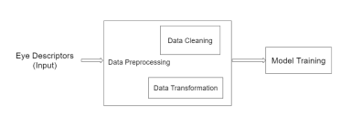Figure 1: Offline Processing

Offline Processing

• Input : Eye movement features recorded during reading and non reading tasks are used as input for the system.

• Data Cleaning : Some values were missing for non dyslexic people. Those missing values are either dropped or replaced with the population mean.

• Data Transformation: All the text data is converted into numeric form so that it can fit into the model while training phase.

• Model Training : Model is trained using some binary classification algorithms such as Logistic Regression, SVM, K-Nearest Neighbors. Among those classifiers, classifier with highest accuracy will be selected.

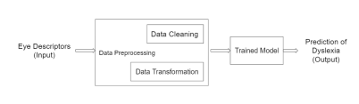

Figure 2: Online Processing

Online Processing

• Input : Eye movement features recorded during reading and non reading tasks are used as input for the system.

• Data Cleaning : Some values were missing for non dyslexic people. Those missing values are either dropped or replaced with the population mean.

• Data Transformation: All the text data is converted into numeric form so that it can fit into the model while training phase.

• Trained Model : The trained model is used to predict whether the person is dyslexic or not.

1. **RESULT AND ANALYSIS**

ALGORITHM DETAILS

The algorithm for developing the system follows the following steps: .

• Using numerous classification methods such as SVM, Logistic Regression, Random Forest, and Naive Bayes to train the data on different classifiers.

• Testing models on the test data: The trained model is then tested on the test data and the values are predicted by the model.

• Comparing various performance metrics: The predicted values are compared to the actual values and several performance metrics are evaluated.

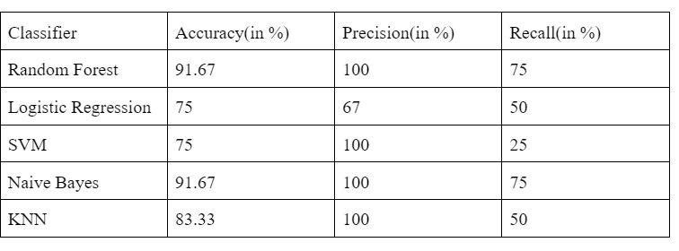

Fig 3 :Result after testing 20% of the Pseudoword and Meaningful Passage Reading Dataset

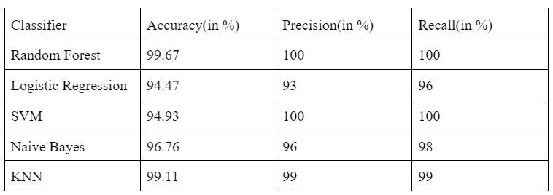

Fig 4:Result after testing 30% of the S1 dataset

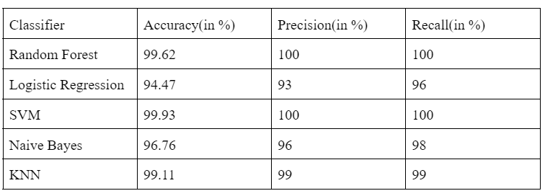

Fig 5:Result after testing 30% of the Provo_corpus-Eye Tracking dataset

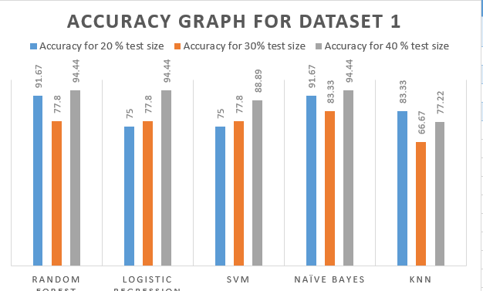

Fig 6:Accuracy comparison for Pseudoword and Meaningful Passage Reading Dataset

.

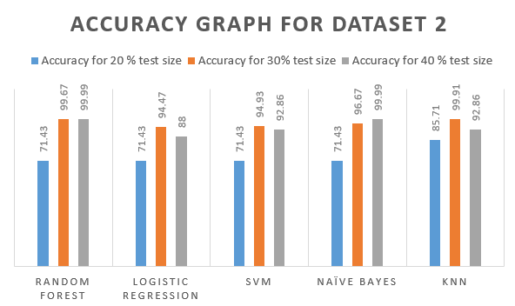

Fig 7:Accuracy comparison for S1 Dataset.

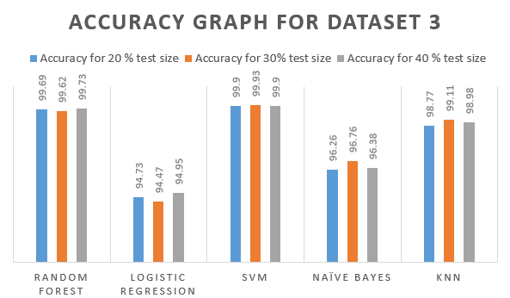

Fig 8:Accuracy comparison for Provo_corpus-Eye Tracking dataset.

We procured three datasets for our paper which was in itself a very difficult task as the dataset was not available or easily accessible. After receiving the datasets we did our work on these datasets and our classification model predicted the results with very good accuracy. To begin, we used a variety of classifiers to train the model for the Pseudoword and Meaningful Passage Reading Dataset, including Random Forest, Logistic Regression, Support Vector Machine, Naive Bayes, and K Nearest Neighbors. Secondly, for the S1 dataset we performed the data preprocessing in which we replaced missing values with population mean and applied various classification techniques to train the model and accuracies are shown in figure 3, 4 and 5. The Provo Corpus-Eyetracking Dataset that we have used had many features. Initially, we performed the data preprocessing in which we first cleaned the data by removing the null value from the dataset and then performed data transformation via label encoding. After that, the processed data was trained with different classification models for various test sizes and results are shown in tables.

1. **CONCLUSION**

Although eye-tracking is useful for screening dyslexia, it's

important to highlight that the methodology isn't based on the assumption that dyslexia is due to a lack of visual understanding or oculomotor control. Only advantage and trouble at which sentences are absorbed by the linguistic structure has an essentially instantaneous effect on eye movements while reading, according to the assumption. Finally, it's crucial to note that not all children who have persistent reading challenges share the same neuropsychological profile. It’s well established, for example, that there’s considerable symptom overlap and a high rate of comorbidity between dyslexia, attention-deficit hyperactivity disorder (ADHD) and language impairment[3-4]. It's also common to recognise several subtypes of dyslexia. As a result, symptomatic creation of a strong screening result is always crucial in order to build a more comprehensive understanding of a person's intellectual profile, and intercession approaches will be tailored to individual needs. Nonetheless, the first and most critical stage in this process is to identify individuals who require assistance early on.

1. **FUTURE WORK AND APPLICATION**

The main objective of the paper was to predict whether the person is dyslexic or not via reading only. This system can further be improved by more accurate diagnosis of the disease via reading, writing and speaking. Availability of the datasets of eye movement tracking is indispensable for detection of dyslexia, so making health care related datasets available for researchers should be given importance. Also more focus should be given to improve the performance and accuracy of the classification model. Another scope of the papert can be taking live data from the subject while he/she is reading using EOG signals and the data can be fed to the model to give accurate results in real-time.

In healthcare systems, the diagnosis of dyslexia is done manually. It requires manual efforts to make prediction of dyslexia.This study proposes a new approach based on machine learning techniques that can predict whether a person is dyslexic or nondyslexic with high accuracy. The system will help to reduce human efforts and errors.

1. **REFERENCES**
2. Nilsson Benfatto M, O qvist Seimyr G,Ygge J, Pansell T, Rydberg A, Jacobson C Screening for Dyslexia Using Eye Tracking duringReading.11(12): e0165508.doi:10.1371/journal.pone.0165508. (PLoS ONE 2016)
3. Guyon I, Weston J, Barnhill S, Vapnik V Gene selection for cancer classification using support vector machines.( Mach Learn 46: 389–422. 2002)
4. Jacobson C Reading Development and Reading Disability. Analyses of Eye Movements and Word Recognition. Dissertation, (Lund University 1998)
5. Fouganthine A Dyslexia from Childhood into Adulthood: A Developmental Perspective on Reading and Writing Disabilities. Dissertation, (Stockholm University 2012)
6. Samantha Thelijjagoda, Mithila Chandrasiri, Dilan Hewathudalla, Pasindu Ranasinghe, Isuru Wickramanayake The Hope: An Interactive Mobile Solution to Overcome the Writing, Reading and Speaking Weaknesses of Dyslexia The 14th International Conference on Computer Science Education August. Toronto, Canada (ICCSE 2019)
7. Prof. Masooda Modak,Omkar Warade,G.Saiprasad,Shweta Shekhar Machine Learning based Learning Disability Detection using LMS 2020 IEEE 5th International Conference on Computing Communication and Automation Galgotias University, Greater Noida, UP, India. Oct 30-31, (ICCCA 2020)
8. Ramis Ileri, Fatma Latifoglu, Esra Demirci New Method to Diagnosis of Dyslexia Using 1D-CNN New Method to Diagnosis of Dyslexia Using 1D-CNN
9. Zeeshan Bhatti Maymoona Bibi Naila Shabbir Augmented Reality based Multimedia Learning for Dyslexic Children 3rd International Conference on Computing, Mathematics and Engineering Technologies (iCoMET 2020)
10. Alae Eddine El Hmimdi Lindsey M Ward , Themis Palpanas and Zo¨ı Kapoula Citation El Hmimdi, A.E.; Ward, L.M.; Palpanas, T.; Kapoula, Z. predicting Dyslexia and Reading Speed in Adolescents from Eye Movements in Reading and Non-Reading Tasks: A Machine Learning Approach (Brain Sci.2021)
11. Ioannis Smyrnakis , Vassilios Andreadakis , Vassilios Selimis , Michail Kalaitzakis , Theodora Bachourou , Georgios Kaloutsakis , George D. Kymionis, Stelios Smirnakis, Ioannis M. Aslanides ADAR: A novel fast-screening method for reading difficulties with special focus on dyslexia (PLOS ONE 2017)
12. YING WANG , XIAOMING WANG AND YAOWU WU A Simple Model of Reading Eye Movement Based on Deep Learning (IEEE 2020)
13. <https://dataverse.harvard.edu/api/datasets/export?exporter=htmlpersistentId=doi>
14. <https://github.com/wxmgo/ey>e movement in reading/blob/master/ProvoCorpusEyetracking Data(sub1-10).csv